# Go With The Flow Game

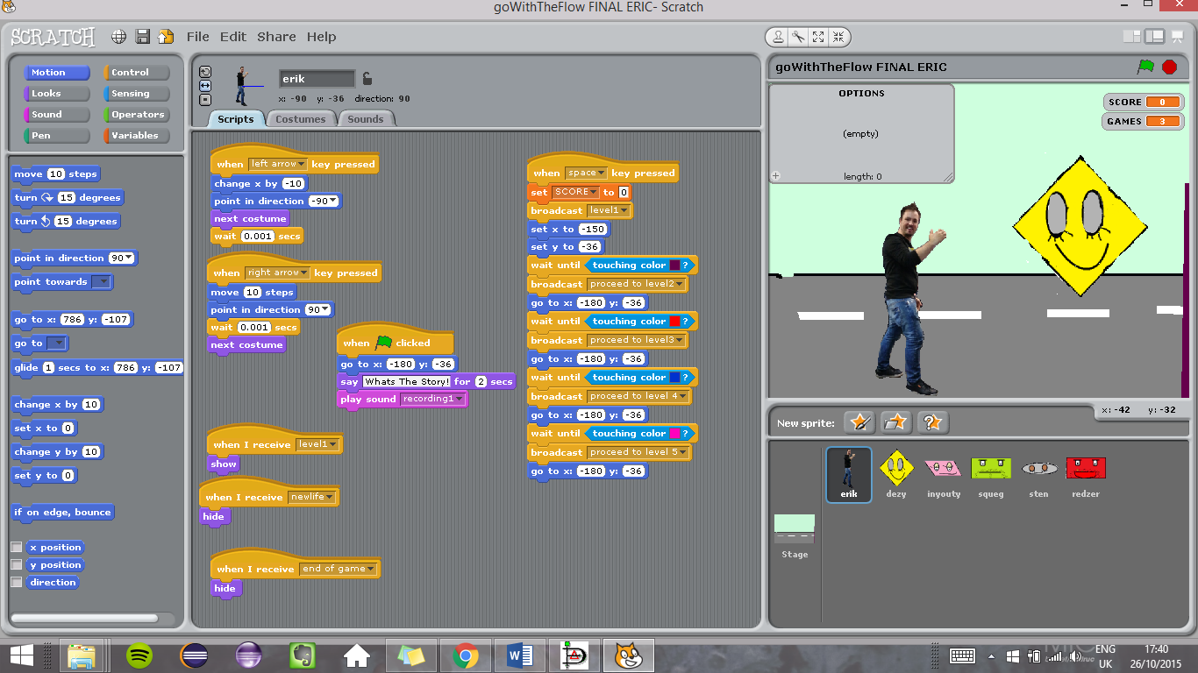

Go with the flow is an interactive and educational game about the functions of Flow Charts. This is a platform game which involves the main character (Eric) who can walk freely around each level of 5 Levels. He encounters the flow chart shapes of diamond, rectangle, oval and parallelogram on levels 1-4. Each character was created by myself via MS paint and have their own characteristics. Each sprite also has an animation of blinking or laughing and prompts a sound when asking the user a question or answer. All sprites and stages were created by myself to avoid using any content on the web. However the only material I have used outside of my own creativity was the theme song at the very end of the game when you do not continue.

"Queens Of The Stone Age - Go With The Flow." *YouTube*. YouTube, n.d. Web. 26 Oct. 2015.

Dezzy Diamond is a diamond who represents looping and decision making. He prompts the user who is controlling the main sprite to answer the question ”**what is the function of a diamond** ?”. If the user gets the answer correct which is either **(loop or decision)** , (**the score)** variable gains 100 points, or if incorrect then the user loses 100 points.

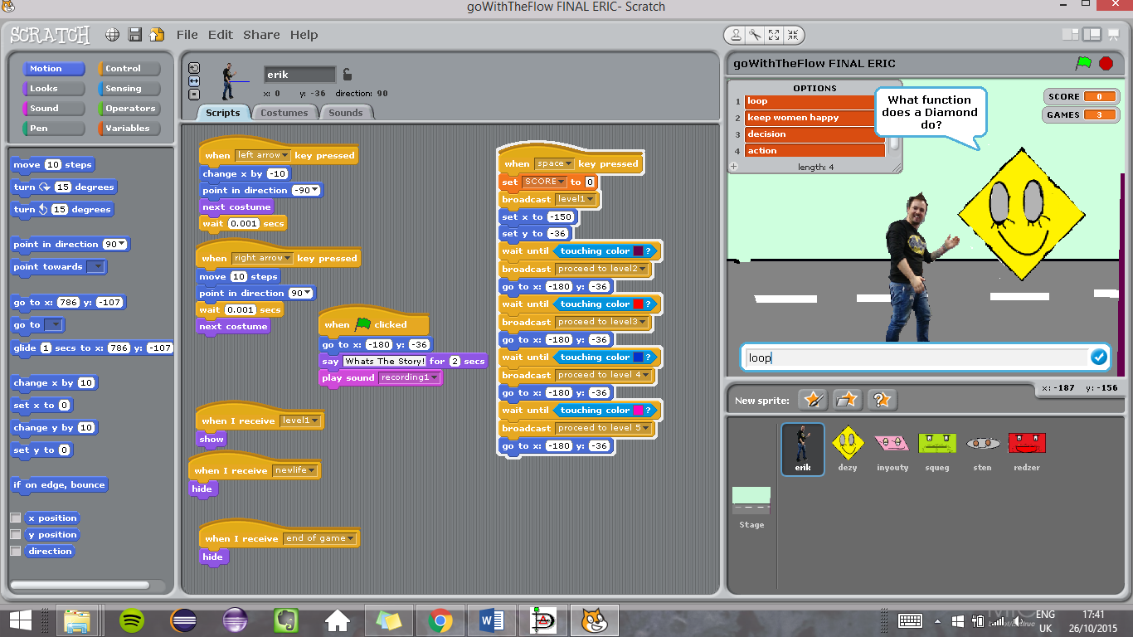

Inyouty is a parallelogram. This sprite does the same characteristic is Dezzy. Asks the question **“what is the function of a parallelogram ?**” The answers are (input and output). The score variable then gains another 100 points. If incorrect then -100 points occurs to the variable score.

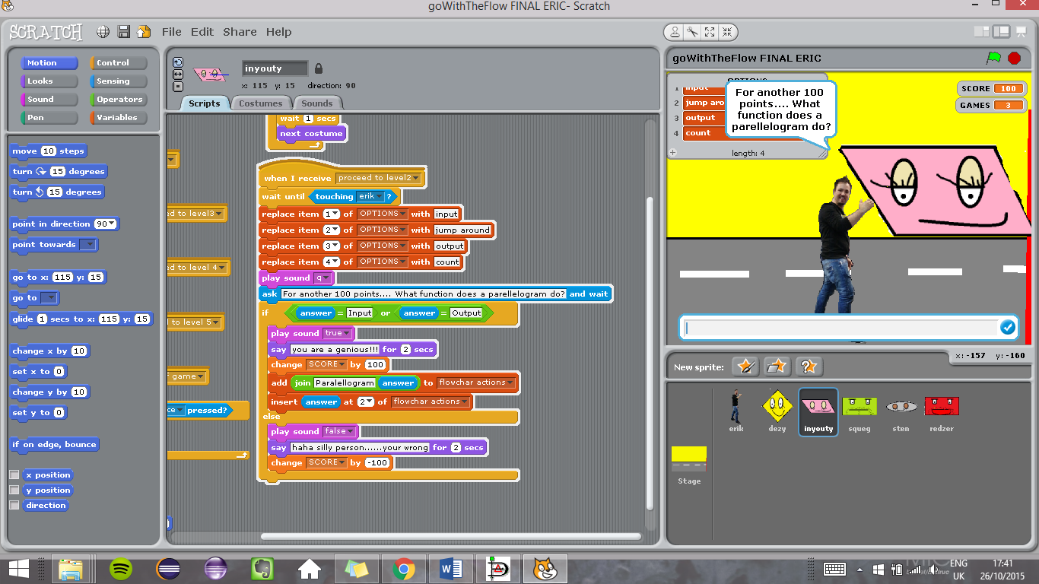

Squeg is a rectangle. The answers to his questions are (action or calculate) This will result in 100 points to score or -100 if not correct.

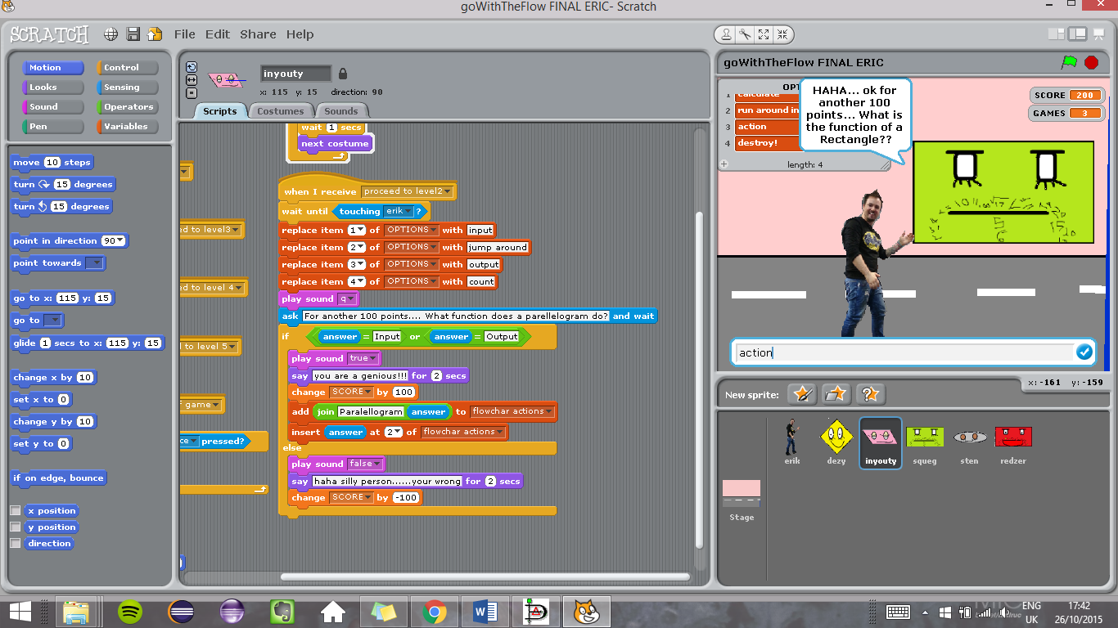

Sten abbreviated from Start End, is an oval shape who asks the question the function of an oval. The answers are (start or end) if correct 100 points to score or -100 to score.

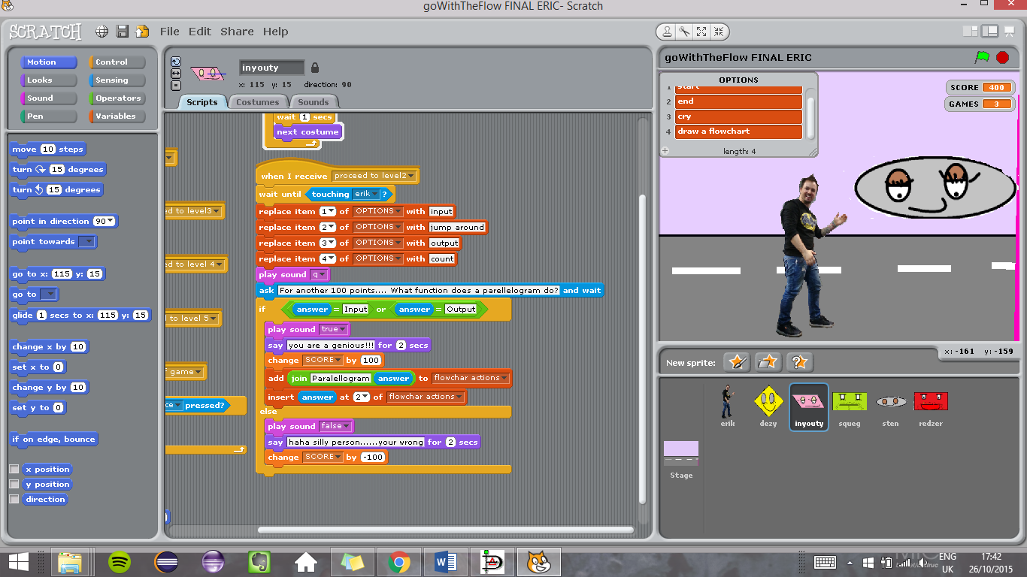

All sprites ask questions which requires the user’s interaction to answer and add up the total of score. If the score is greater than 250 you win the game. If less than 250points you loose and only have 3 games.

**Games** is another variable and if all 3 are gone then the game is over.

The main sprite (Eric) has the ability to walk freely onto 5 different levels each encountering a different "Boss" who is represented by a shape/character.

An array/list was created to hold different answers to the questions that sprites ask. This is to stop the user from entering an answer out of range of the question. If else statements were used also in each of the boss questions also using OR operators. If the question was correct the score would increment by 100 or else the score would decrement by -100.

A **continue** variable was also created for once a game is over a countdown clock appears to the User to continue counting downwards from 10 seconds to continue.

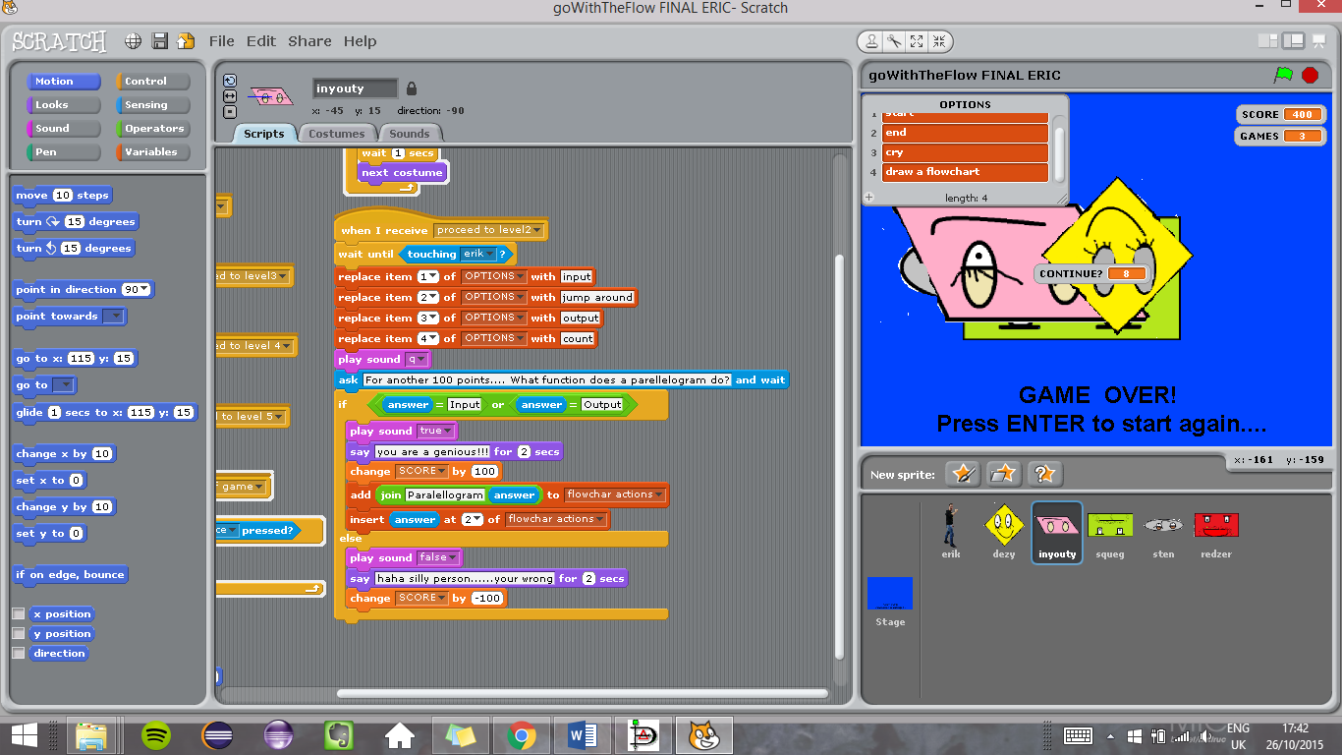

# Game Instructions

1. YOU MUST CLICK THE FLAG TO BEGIN THE ANIMATIONS OF THE GAME. THIS IS THE STARTING POINT.
2. Press Spacebar to begin
3. Dezzy will ask a question. The answers are in the list. action or loop
4. Inyouty will ask a question. The answers are in the list. input or output
5. squeg will ask a question. The answers are in the list. action or process
6. Sten will ask a question. The answers are in the list. start or end
7. If you got all questions correct you win the game and have the option to play again. Yes or no will start the game again. Then the screen will prompt you for a spacebar
8. If you lose you will be prompted to play again. You only have 3 lives until the game ends. You can press enter key to start the game over.

# Flowchart for Go with The Flow

See Flowchart Folder for .DIA file (FLOWCHARTforGWTF)

See Flowchart Folder for .PDF file (FLOWCHARTforGWTF)